**About the BMC Remedy IT Service**

**Management Suite**

**BMC Atrium CMDB 2.0.1**

The BMC Atrium CMDB 2.0.1 is installed prior to Asset Management, Change

Management, and Service Desk (including Incident Management and Problem

Management). It stores information about configuration items (CIs) and their

relationships in an inheritance-based data model, and has the ability to reconcile

data from different sources. The BMC Atrium CMDB 2.0.1 provides a “single

source of truth” about your IT environment, enabling other BMC applications to

manage CIs, predict the impact of configuration changes, and perform other

Business Service Management (BSM) functions.

**BMC Remedy Asset Management 7.0**

The BMC Remedy Asset Management application lets IT professionals track and

manage enterprise configuration items (CIs)—and their changing relationships—

throughout the entire asset life cycle. As part of the BMC Remedy ITSM Suite,

Asset Management is integrated with BMC Remedy Service Desk (which contains

the BMC Remedy Incident Management and BMC Remedy Problem Management

applications), BMC Remedy Change Management, and BMC Service Level

Management, and offers flexibility to support customized business processes.

**BMC Remedy Change Management 7.0**

Using ITIL®-compatible best practices, BMC Remedy Change Management

provides IT organizations with the ability to manage changes by enabling them to

assess impact, risk, and resource requirements, and then create plans and

automate approval functions for implementing changes. It provides scheduling

and task assignment functionality, and reporting capabilities for reviewing

performance and improving processes. Because Change Management is

integrated with the BMC Atrium CMDB, Change Management lets you relate

changes to other records, such as CIs (including services) and incidents.

**BMC Remedy Incident Management 7.0**

BMC Remedy Incident Management is used to manage incidents. Incident

management is reactive, and is typically initiated in response to a customer call or

automated event. An example of an automated event might be an alert from a

monitoring system, such as BMC Service Impact Management (BMC SIM). The

primary goal of the incident management process, according to ITIL standards, is

“to restore normal service operation as quickly as possible with minimum

disruption to the business, thus ensuring that the best achievable levels of

availability and service are maintained.”

An incident is any event that is not part of the standard operation of a service and

that causes an interruption to or a reduction in the quality of that service. Normal

service operation is the operation of services within the limits specified by Service

Level Management (SLM).

**BMC Remedy Problem Management 7.0**

BMC Remedy Problem Management is used to manage problem investigations,

known errors, and solution database entries. Problem management can

proactively prevent the occurrence of incidents, errors, and additional problems.

A problem investigation helps an IT organization get to the root cause of incidents.

It initiates actions that help to improve or correct the situation, preventing the

incident from recurring.

After a problem investigation identifies the cause, this information can result in

either a known error or a solution database entry. A known error is a problem that

has been successfully diagnosed and for which a temporary workaround or

permanent solution has been identified. A solution database entry contains

information that might be required to provide or restore a service.

**BMC Service Request Management**

BMC Service Request Management (SRM) allows IT to define offered services,

publish those services in a service catalog, and automate the fulfillment of those

services for their users. With SRM, users have the ability to help themselves, which

reduces the requests coming into the service desk. This enables IT to focus on more

mission-critical activities, such as resolving incidents related to service failures and

restoring critical services. SRM also provides the ability to automate workflow for

each service, enforcing consistency of process and faster fulfillment of the request.

**BMC Service Level Management 7.0**

BMC Service Level Management enables a service provider, such as an IT

organization, a customer support group, or an external service provider, to

formally document the needs of its customers or lines of business using service

level agreements, and provide the correct level of service to meet those needs.

Service Level Management also provides a means to review, enforce, and report on

the level of service provided. It streamlines the most important task of all, which is

the communication between a service provider and its customers. Multiple service

targets can be defined and monitored, acting as a bridge between IT service

support and IT operations. This enables costs to be controlled and helps to provide

a consistent level of service in support of key business services.

**Introduction**

🡪You can use the ITSM Data Management tool to import foundation data into ITSM

7.0. The following topics are provided*:*

! When to use the ITSM Data Management tool (page 14)

! Overview of the bulk load process (page 16)

! Components of the tool (page 17)

! Hardware and software prerequisites (page 19)

! Performance benchmarks (page 19)

**When to use the ITSM Data Management tool**

You can use the ITSM Data Management tool whenever you wish to import

foundation data, such as in the following scenarios:

! A new installation of ITSM

! An existing installation of ITSM to which another company, business unit,

department, or other group is being added

! Migration from a previous version of ITSM

Foundation data refers to configuration data that applies to all of the ITSM

applications, such as companies, sites, people, and categorization. Figure 1-1

illustrates the three levels of data in ITSM.

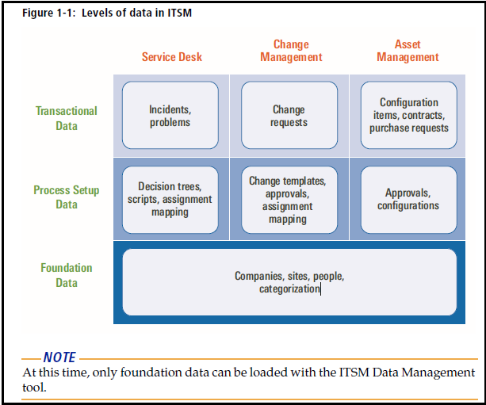

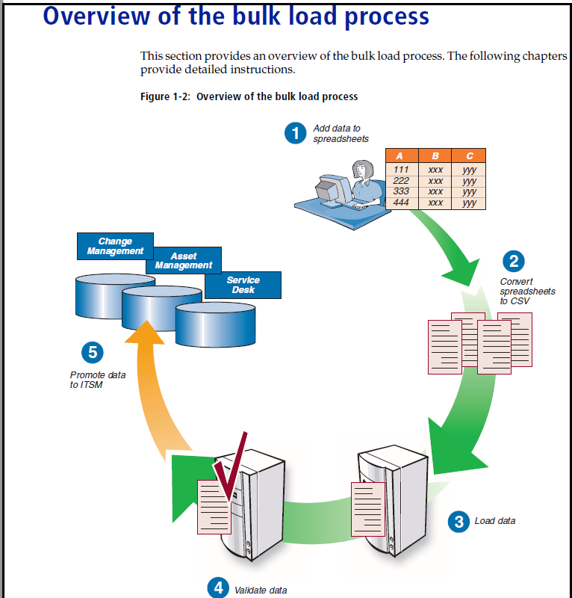

The bulk load process consists of the following steps:

Step 1 Add data to spreadsheets.

The ITSM Data Management tool includes Excel workbooks. Each tab on the Excel

workbook corresponds to a form in ITSM 7.0, as described in Appendix A, “How

tabs map from spreadsheet to target form.”

For instructions, see Chapter 3, “Completing the spreadsheets.”

Step 2 Convert data in spreadsheets to CSV files.

The tool includes macros to convert the spreadsheet data to the appropriate CSV

files, as described in “Creating the CSV files” on page 36.

Step 3 Load the data.

You must perform steps to load the data. For instructions, see “Editing the data

load batch file” on page 36, and “Running the batch file” on page 37.

Step 4 Validate the data.

Step 5 Promote the data into ITSM.

**Components of the tool**

The ITSM Data Management tool includes the following components:

! **Excel workbook files for loading data**—Each of these workbook files has

individual tabs that correspond to the different foundation data structures that

can be imported. The following workbook files are included:

! Company.xls

! Financials.xls

! GenericCatalog.xls

! Geography.xls

! Location.xls

! OperationalCatalog.xls

! People.xls

! PeopleOrg.xls

! ProductCatalog.xls

! SupportGroup.xls

! SystemSetup.xls

**Excel conversion files**—Each data load workbook has a corresponding

conversion file. Each conversion file contains a macro to convert the individual

tabs in the data load workbook into separate files in CSV format. The following

conversion files are included:

! CompanyCSV.xls

! FinancialsCSV.xls

! GenericCatalogCSV.xls

! GeographyCSV.xls

! LocationCSV.xls

! OperationalCatalogCSV.xls

! PeopleCSV.xls

! PeopleOrgCSV.xls

! ProductCatalogCSV.xls

! SupportGroupCSV.xls

! SystemSetupCSV.xls

! **Definition files**—The DEF files contain the necessary AR System staging forms

and AR System workflow to manage, validate, and promote the data that you

are importing into the appropriate ITSM forms.

! **Mapping file list**—Foundation.lst lists the mapping files that are used during

the automated import.

! **Data load batch file**—Foundation.bat automates the importing of the data in

the CSV files and makes sure that they are imported in the correct order. Data is

imported into a staging area for validation before you promote the data into the

target forms.

! **ARX files**—These files contain back-end data required by the ITSM Data

Management tool.

! **Import mapping files**—Files with the extension .arm (AR Mapping) are import

mapping files used by the ITSM Data Management tool.

**Performance benchmarks**

The following table shows how many records per hour were processed by the

ITSM Data Management tool in BMC Software’s performance lab.

**Table 1-2: Performance benchmarks for foundation data**

**Task Throughput (records per hour)**

Load people data from the CSV file to staging

forms

225,000

Validate people data in staging forms 1,000,000

Promote people data into ITSM forms 220,000

The test data for these performance benchmarks consisted of 238,000 People

records, which included 1,200 support staff.

The AR System server was configured for multi-threading, as described in

“Configuring performance enhancements” on page 25.

For Oracle configuration, the initialization parameters were set as follows:

! cursor_share=force

! optimizer_index_cost_adj=25

! optimizer_index_caching=90

! sga_target=800M

! pga_aggregate_target=200M

! open_cursors=300

Data files were on one hard drive, while all the online redo log files were on

another dedicated hard drive.

***NOTE***

After starting validation, and after starting promotion, the Data Load console was

closed to maximize throughput.

**Installing and configuring the**

**tool**

🡪Follow these steps to install and configure the tool:

Step 1 Turn on Development Cache Mode.

Step 2 Run the ITSM Data Management tool installer.

BMC recommends that you run the installer on your workstation. The installer

installs components, such as the Data Load Console to your AR System server. It

installs other components, such as the data load spreadsheets, to your workstation.

Step 3 Turn off Development Cache Mode.

Step 4 Optionally, to enhance bulk data load performance, you can configure the tool to

use multi-threading.

The following topics are provided*:*

! Turning on Development Cache Mode (page 22)

! Running the ITSM Data Management tool installer (page 22)

! Turning off Development Cache Mode (page 24)

! Configuring performance enhancements (page 25)

**Turning on Development Cache Mode**

To install the ITSM Data Management tool, you must first turn on Development

Cache Mode. After you do this, run the ITSM Data Management tool installer.

When the installer finishes running, turn off Development Cache Mode.

***NOTE***

After you turn on Development Cache Mode in the following procedure, you must

restart the AR System server.

􀀀 **To turn on Development Cache Mode**

1 Open BMC Remedy Administrator.

2 Log in to the AR System server to which you are importing data.

3 Select the appropriate server.

4 Choose File > Server Information.

The Server Information window appears.

5 Click the Configuration tab.

6 Select Development Cache Mode.

7 Click OK.

The Server information window closes and the system prompts you to restart the

AR System server.

8 Close BMC Remedy Administrator, and then restart the AR System server.

**Running the ITSM Data Management tool**

**installer**

Follow this procedure to install the ITSM Data Management tool.

􀀀 **To install the ITSM Data Management tool**

1 Run setup.exe.

BMC recommends that you run the installer from your Windows workstation.

After the installer loads, the ITSM Data Management Tool window appears,

displaying the Introduction screen of the installer.

***NOTE***

Depending on your Windows security settings, you might see a Windows Security

Alert.

2 Click Next to continue.

The End User License Agreement appears.

3 Accept the terms of the license agreement and click Next to continue.

You are prompted for the installation location. The default location is

C:\Program Files\BMC Software\BMC Remedy ITSM Data Management Tool. You can

change this location, if appropriate.

4 Click Next to continue.

After the tool is configured for your environment, you are prompted to enter

connection information for your AR System server. The installer requires this

information so that it can install the necessary DEF and ARX files.

**Figure 2-1: BMC Remedy ITSM Data Management Tool—Connection Information screen**



5 Complete the Connection Information screen as described in Table 2-1.

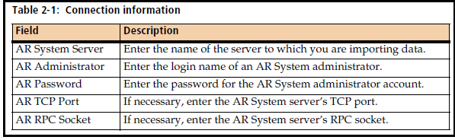

6 Click Next to continue.

After the installer connects to your AR System server, the Version Summary screen

appears, displaying a table of currently installed ITSM products, and their

corresponding version numbers, patch levels, and installed languages

***IMPORTANT***

If any of the installed applications are not at version 7.0 patch 006 or later, your system

does *not* meet the prerequisites of the ITSM Data Management tool. You must

cancel installation of the tool. Prerequisites for the tool are described in “Hardware

and software prerequisites” on page 19.

7 Click Next to continue.

The pre-installation summary displays the product name, installation folder, and

disk space requirements.

8 Click Install to install the tool.

During installation, the progress is displayed. When the tool has been installed, the

screen displays the message, “Execution complete.”

9 Click Next to continue.

The installer displays the status of the installation.

10 Click Done to exit the installer.

11 If you ran the installer on the server, copy the files from the installation location

(default of C:\Program Files\BMC Software\BMC Remedy ITSM Data Management

Tool) to the workstation on which you will run the tool.

**Turning off Development Cache Mode**

After you install the tool, turn off Development Cache Mode.

***NOTE***

After you turn off Development Cache Mode, you must restart the AR System

server.

􀀀 **To turn off Development Cache Mode**

1 Open BMC Remedy Administrator.

2 Log in to the AR System server to which you are importing data.

3 Select the appropriate server.

4 Choose File > Server Information.

The Server Information window appears.

5 Click the Configuration tab.

6 Clear Development Cache Mode.

7 Click OK.

The Server Information window closes and the system prompts you to restart the

AR System server.

8 Close BMC Remedy Administrator, and then restart the AR System server.

**Configuring performance enhancements**

If you are bulk loading significant amounts of data, you will see performance

improvements by:

! Setting the Next Request ID Block Size to 40.

This setting enhances performance when importing data from the CSV files into

the staging forms.

! Using multi-threading.

Multi-threading allows multiple chunks of data to be processed at the same

time. You can configure multiple threads to be run simultaneously, depending

on how powerful your server is.

***IMPORTANT***

If you configure these performance enhancements, when the ITSM Data

Management tool is running validation or promotion, the AR System server

utilizes 100 percent CPU capacity to achieve maximum throughput. This means

that during validation and promotion, the AR System server is *not* responsive to

other requests.

To configure the tool to use multi-threading, you must:

Step 1 Configure the AR System server information for multi-threading.

Step 2 Configure the CAI:Plugin Registry form.

Step 3 Set the plugin filter API threads

**Setting the Next Request ID Block Size**

You can set this performance enhancement, regardless of whether you configure

multi-threading.

􀀀 **To set the Next ID Block Size**

1 Open BMC Remedy Administrator.

2 Log in to the AR System server to which you are importing data.

3 Select the appropriate server.

4 Choose File > Server Information.

5 Click the Configuration tab.

6 Set the Next Request ID Block Size to 40.

7 If you are configuring the AR System server for multi-threading, continue with the

next procedure, which is on this screen. Otherwise, click OK to save your settings.

**Configuring the AR System server for multi-threading**

To see performance improvements from multi-threading, you must configure

several settings for AR System server information.

􀀀 **To configure multi-threading**

1 If it is not already open, open the Server Information window.

2 Click the Server Ports and Queues tab.

**Figure 2-2: Server Information window—Server Ports and Queues tab**



3 If no private server queue exists, create one by performing the following steps:

a Click the “Click to add” row.

b For Type, select Private.

c Select an available RPC Program Number.

4 Set (or modify) the minimum and maximum number of threads as indicated in

Table 2-2.

**Table 2-2: Server queue configuration**

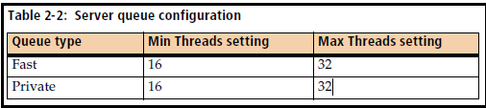

5 Make sure that the Plug-in Loopback RPC Program Number is set to the private

queue’s RPC Program Number.

Take note of this number. You will need it in subsequent steps, after you close this

window.

6 Click OK to save your changes.

**Configuring the CAI:Plugin Registry form**

You must configure the CAI:Plugin Registry form as indicated in the following

steps.

􀀀 **To configure the CAI:Plugin Registry form**

1 Open BMC Remedy User.

2 Log in to the AR System server as an administrator.

3 Open the CAI:Plugin Registry form.

4 Click Search to search for the record.

5 If no record is found, create a new record.

**Figure 2-3: CAI Plug-in Registry form**



6 Set the Private Queue # to the RPC Program Number.

7 Set the Number of Threads to 16.

The number of threads must be within the minimum and maximum number that

you set for the Private server queue. BMC recommends 16 threads.

8 Click Save.

**Setting the plugin filter threads**

To see performance improvements from multi-threading, you set the plugin filter

threads.

􀀀 **To set the plugin filter threads**

1 On the server, open the AR System configuration file in a text editor.

On a Windows server, the configuration file is ar.cfg. On a UNIX® server, the file

is ar.conf.

2 Add the following line to the end:

Plugin-Filter-API-Threads: 8 40

3 Save your changes.

4 Restart the AR System server.

**Completing the spreadsheets**

Before you can import data, you must complete the appropriate data load

spreadsheets.

The following topics are provided*:*

! Understanding the spreadsheets (page 30)

! Populating data in the spreadsheets (page 31)